Incident Report 12996: Admin Log In

Date: 5-25-2022 (DS)

# Executive Summary:

ProsperSec was contacted by The Tech Academy to conduct penetration testing on a new Juice Shop application. The main goal was to see if admin could be reached without needing a password.

**Results**:

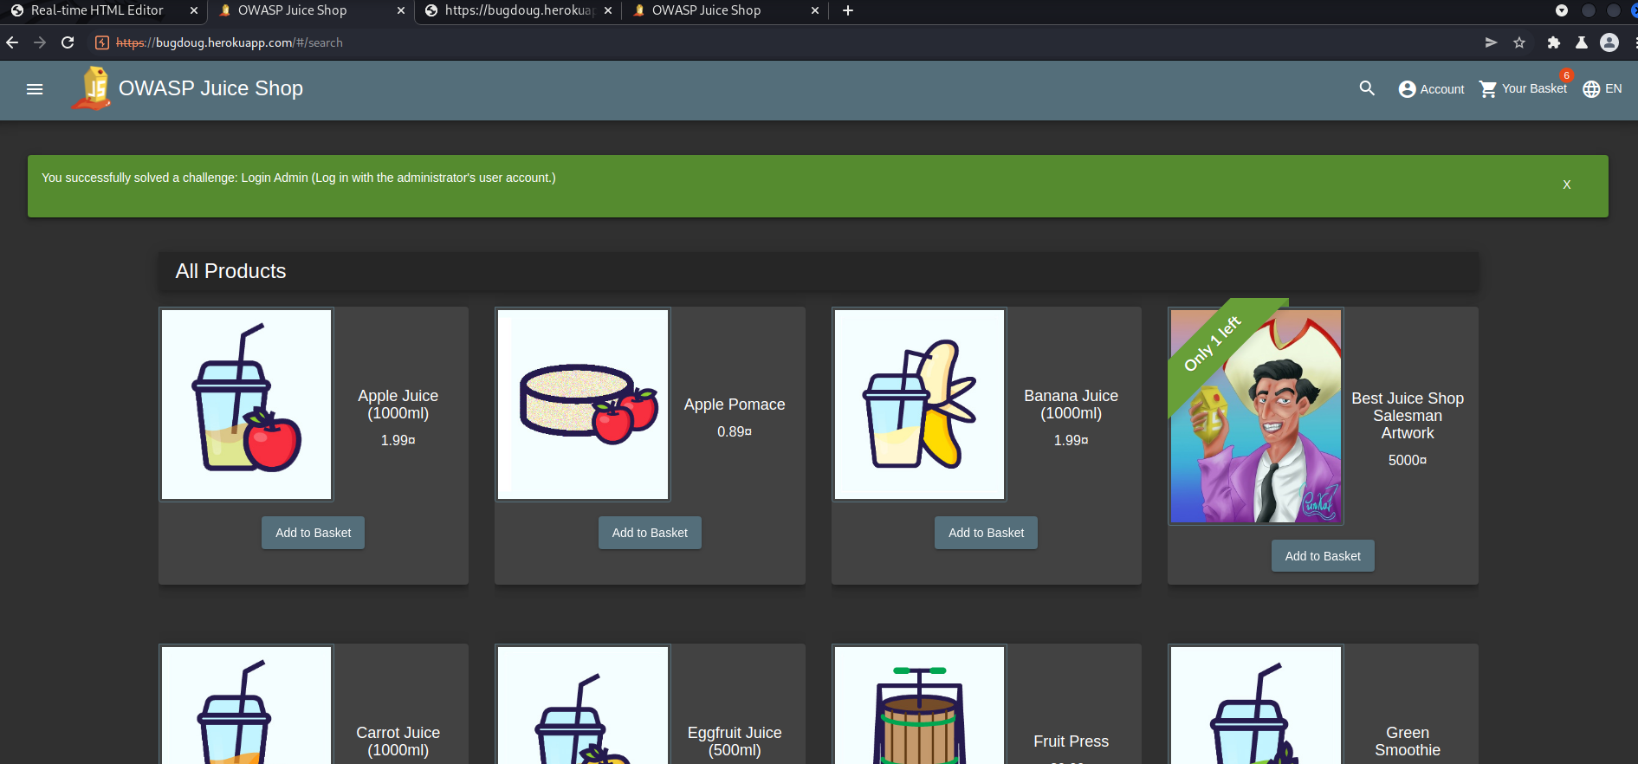

**Application Details:**

Application URL: bugdoug.herokuapp.com/#/login

User Account: admin@juice-sh.op

**Attack Narrative:**

After a few attempts at different things and breaking some things in the process, I was able to input a SQL injection in the login screen which bypassed login by commenting it out using (‘or 1=1- -).

**Conclusion:**

ProsperSec was contracted to find vulnerabilities in the application, Juice store is unsafe due to a major breach in the admin account using a very simple injection. The result was I was able to get into the admin account and potentially access more information or hold the application for ransom.

_____________________________________________________________________________________